Paging using a translation lookaside buffer (tlb)
28430093 – Alwyn Barnard – ITRW 316 2019

Table of Contents
Introduction 2
Page Tables 2
Translation Lookaside Buffer (TLB) 2
Page Replacement Algorithms 3
FIFO (First-In-First-Out) Page Replacement Algorithm 3
Least Recently Used (LRU) Page Replacement Algorithm 3
Local and Global Page Allocation 3
Summary 4
GUI of Paging Program 5
Program Code 5
References 8

Introduction
Virtual Memory is a concept that was first created in 1961 by J. Fotheringham (Fotheringham, 1961). The idea behind this concept is that every program on a computer has its own address space and that is broken up into smaller chunks called pages. The reason for the chunking of pages is that larger programs are basically too large for the computer to store and process and execute.
Pages are mapped onto physical memory spaces, since pages are made up of contiguous address ranges.

Most virtual memory systems use the concept of Paging. Every program on a computer references a set of memory addresses that executes instructions by copying contents of the memory address that has been indexed using a base and segment register. These program-generated addresses are called virtual addresses and are part of the virtual address space. Virtual addresses are maintained and created by the MMU (Memory Management Unit) (Tanenbaum & Bos, 2015)

Page Tables
The typical functioning of a Page Table in the MMU can be seen in the below figure: (Tanenbaum & Bos, 2015).
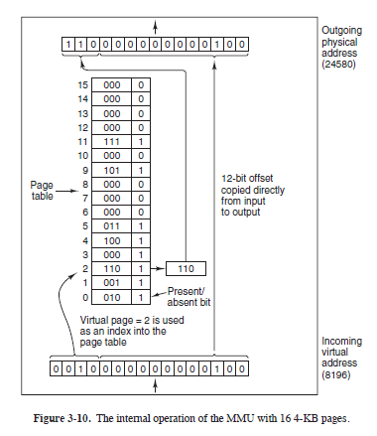

Translation Lookaside Buffer (TLB)
The TLB is used to speed up paging and to address two major issues: (1) The mapping from virtual address to physical address has to be fast [less than one clock cycle] and (2) If the virtual address space is very large, the Page table will be large too. This can be problematic as most computers can handle 32-bit addresses with a 4 kilobyte page size. This means that the 32-bit address can have 1 million pages (Tanenbaum & Bos, 2015).

The Translation Lookaside Buffer is a sort of cache of the Page table. It stores the pages that are currently being referenced or used and can make space for those pages that are being used right now, and that is not already in the TLB by swapping out these pages with others that are in physical memory.

Page Replacement Algorithms
Replacing a page in the TLB can be done in various ways, but we use specific algorithms to make the replacement thereof as efficient and accurate as possible.
I will only be looking at a few algorithms in this report as the others have been covered in great detail elsewhere.

FIFO (First-In-First-Out) Page Replacement Algorithm
Consider this analogy: In the Klipoog Cafeteria there are fridges filled with Coke bottles. To place them there someone had to go inside (to the back) of the queue and insert them. The first one inserted is the first one that will be taken by a customer and the second one will be taken by the next customer.
Just like in the above analogy, we can conclude that the first page which is technically the oldest, will be replaced first. And the second page, which is the second eldest will be replaced second (Tanenbaum & Bos, 2015).

Least Recently Used (LRU) Page Replacement Algorithm
Just like its name states, here the age of each page is stored in the TLB, and the eldest page is then removed. The difference between LRU and FIFO is that whenever a page is used in LRU then the page’s age is set to 1 and all the others are increased. Thus, the page that was truly used last will be youngest, and the eldest page will be the one that was used the longest time ago (Tanenbaum & Bos, 2015).

Local and Global Page Allocation
See below figure from Tanenbaum & Bos, 2015:
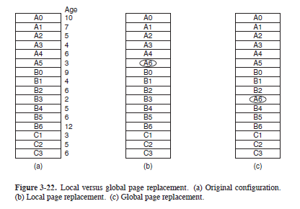
Local Page Replacement will look at only the specific process’ different pages and replace one of those pages leaving the other processes (e.g. B and C). Above, we are Locally replacing A5 with the next available page which is A6. If we were working with the Global Policy then (as in figure 3-22-c) we would have replaced the eldest page in of ALL the working pages in any process.

Summary
Virtual Memory consists of mapping chunks of programs onto a Page table by using a virtual address. When we want to speed this process up we use a Translation Lookaside Buffer to act like a Page Table Cache. The replacement of the pages are done using various algorithms to ensure that it is done optimally and effectively.

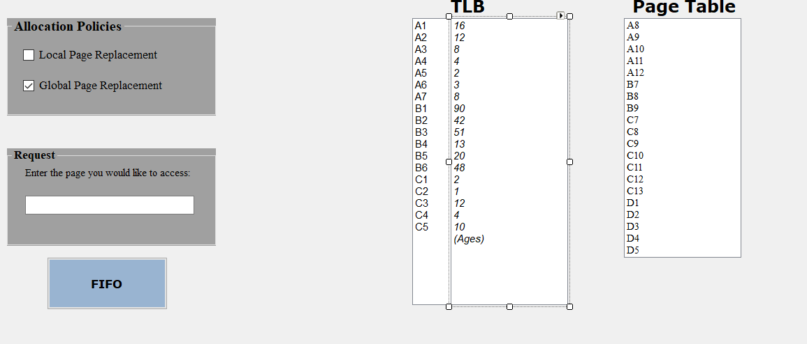
GUI of Paging Program

Program Code
using System;
using System.Collections.Generic;
using System.ComponentModel;
using System.Data;
using System.Drawing;
using System.Linq;
using System.Text;
using System.Threading.Tasks;
using System.Windows.Forms;
using System.Collections;

namespace PagingWTLB
{
public partial class Form1 : Form
{
ArrayList Tlb = new ArrayList(); //TLB Values
ArrayList TlbAges = new ArrayList(); // TLB Ages
ArrayList Pagetable = new ArrayList(); //Page Table Values
ArrayList Breakdown = new ArrayList(); //Element breakdown for local page replacement algorithm
string policy = "G"; //Replacement Policy. Local vs Global
int Max = 0;
int MaxNommer;
public Form1()
{
InitializeComponent();
Tlb.AddRange(lbxTLB.Items);
TlbAges.AddRange(lbAges.Items);
TlbAges.RemoveAt(TlbAges.Count - 1);
Pagetable.AddRange(lbxPT.Items);
policy = "G";
}

private void btnFIFO_Click(object sender, EventArgs e)
{
string Waarde = txtRequest.Text;
bool Found = false;
for (int i = 0; i < Tlb.Count; i++)
{
if (Waarde == Tlb[i].ToString())
{
MessageBox.Show("Found in TLB");
Found = true;
goto WasFound;
}
}

if (Found == false) //Wasnt found in TLD; Search for in PT
{
for (int i = 0; i < Pagetable.Count; i++)
{
if (Waarde == Pagetable[i].ToString())
{
MessageBox.Show("Found in Pagetable");
Found = false;
break;
}
}
}
if (Found == false)
{
Replacement(Waarde, 0, Tlb.Count);
lbxTLB.Items.Clear();
lbAges.Items.Clear();
for (int i = 0; i < Tlb.Count; i++)
{
lbxTLB.Items.Add(Tlb[i].ToString());
lbAges.Items.Add(TlbAges[i].ToString());
}
lbAges.Items.Add("(Ages)");
lbxPT.Items.Clear();
for (int i = 0; i < Pagetable.Count; i++)
{
lbxPT.Items.Add(Pagetable[i].ToString());
}
}
public void Replacement(string waarde,int start, int stop)
{
Max = 0;
MaxNommer = 0;
for (int i=start;i<stop;i++)
{
if (Max < Convert.ToInt16(TlbAges[i]))
{
Max = Convert.ToInt16(TlbAges[i]);
MaxNommer = i;
}
}
Tlb.RemoveAt(MaxNommer);
TlbAges.RemoveAt(MaxNommer);
Tlb.Insert(MaxNommer, waarde);
TlbAges.Insert(MaxNommer, 1);
Pagetable.Remove(waarde);
}

public void PolicyExecution()
{
string EersteLetter = Tlb[0].ToString().Substring(0, 1);

Breakdown.Add(EersteLetter);
Breakdown.Add(0);
for (int i=0;i<Tlb.Count;i++)
{
if (EersteLetter != Tlb[i].ToString().Substring(0, 1))
{
Breakdown.Add(i - 1);
EersteLetter = Tlb[i].ToString().Substring(0, 1);
Breakdown.Add(EersteLetter);
Breakdown.Add(i+1);
}
}
Breakdown.Add(Tlb.Count - 1);
}
public void LocalExecution(string LetterWaarde,string waarde2)
{
for (int i=0;i<Tlb.Count;i++)
{
if (LetterWaarde.Substring(0,1) == Breakdown[i].ToString())
{
Replacement(waarde2, Convert.ToInt16(Breakdown[i + 1]), Convert.ToInt16(Breakdown[i + 2]));
}
}
}
}
}

References
Fotheringham, J.: ‘‘Dynamic Storage Allocation in the Atlas Including an Automatic Use of a Backing Store,’’ Commun. of the ACM, vol. 4, pp. 435–436, Oct. 1961.

Tanenbaum, A. S. & Bos, H. 2015. Modern operating systems. 4th ed. Upper Saddle River, NJ: Pearson Prentice Hall.

